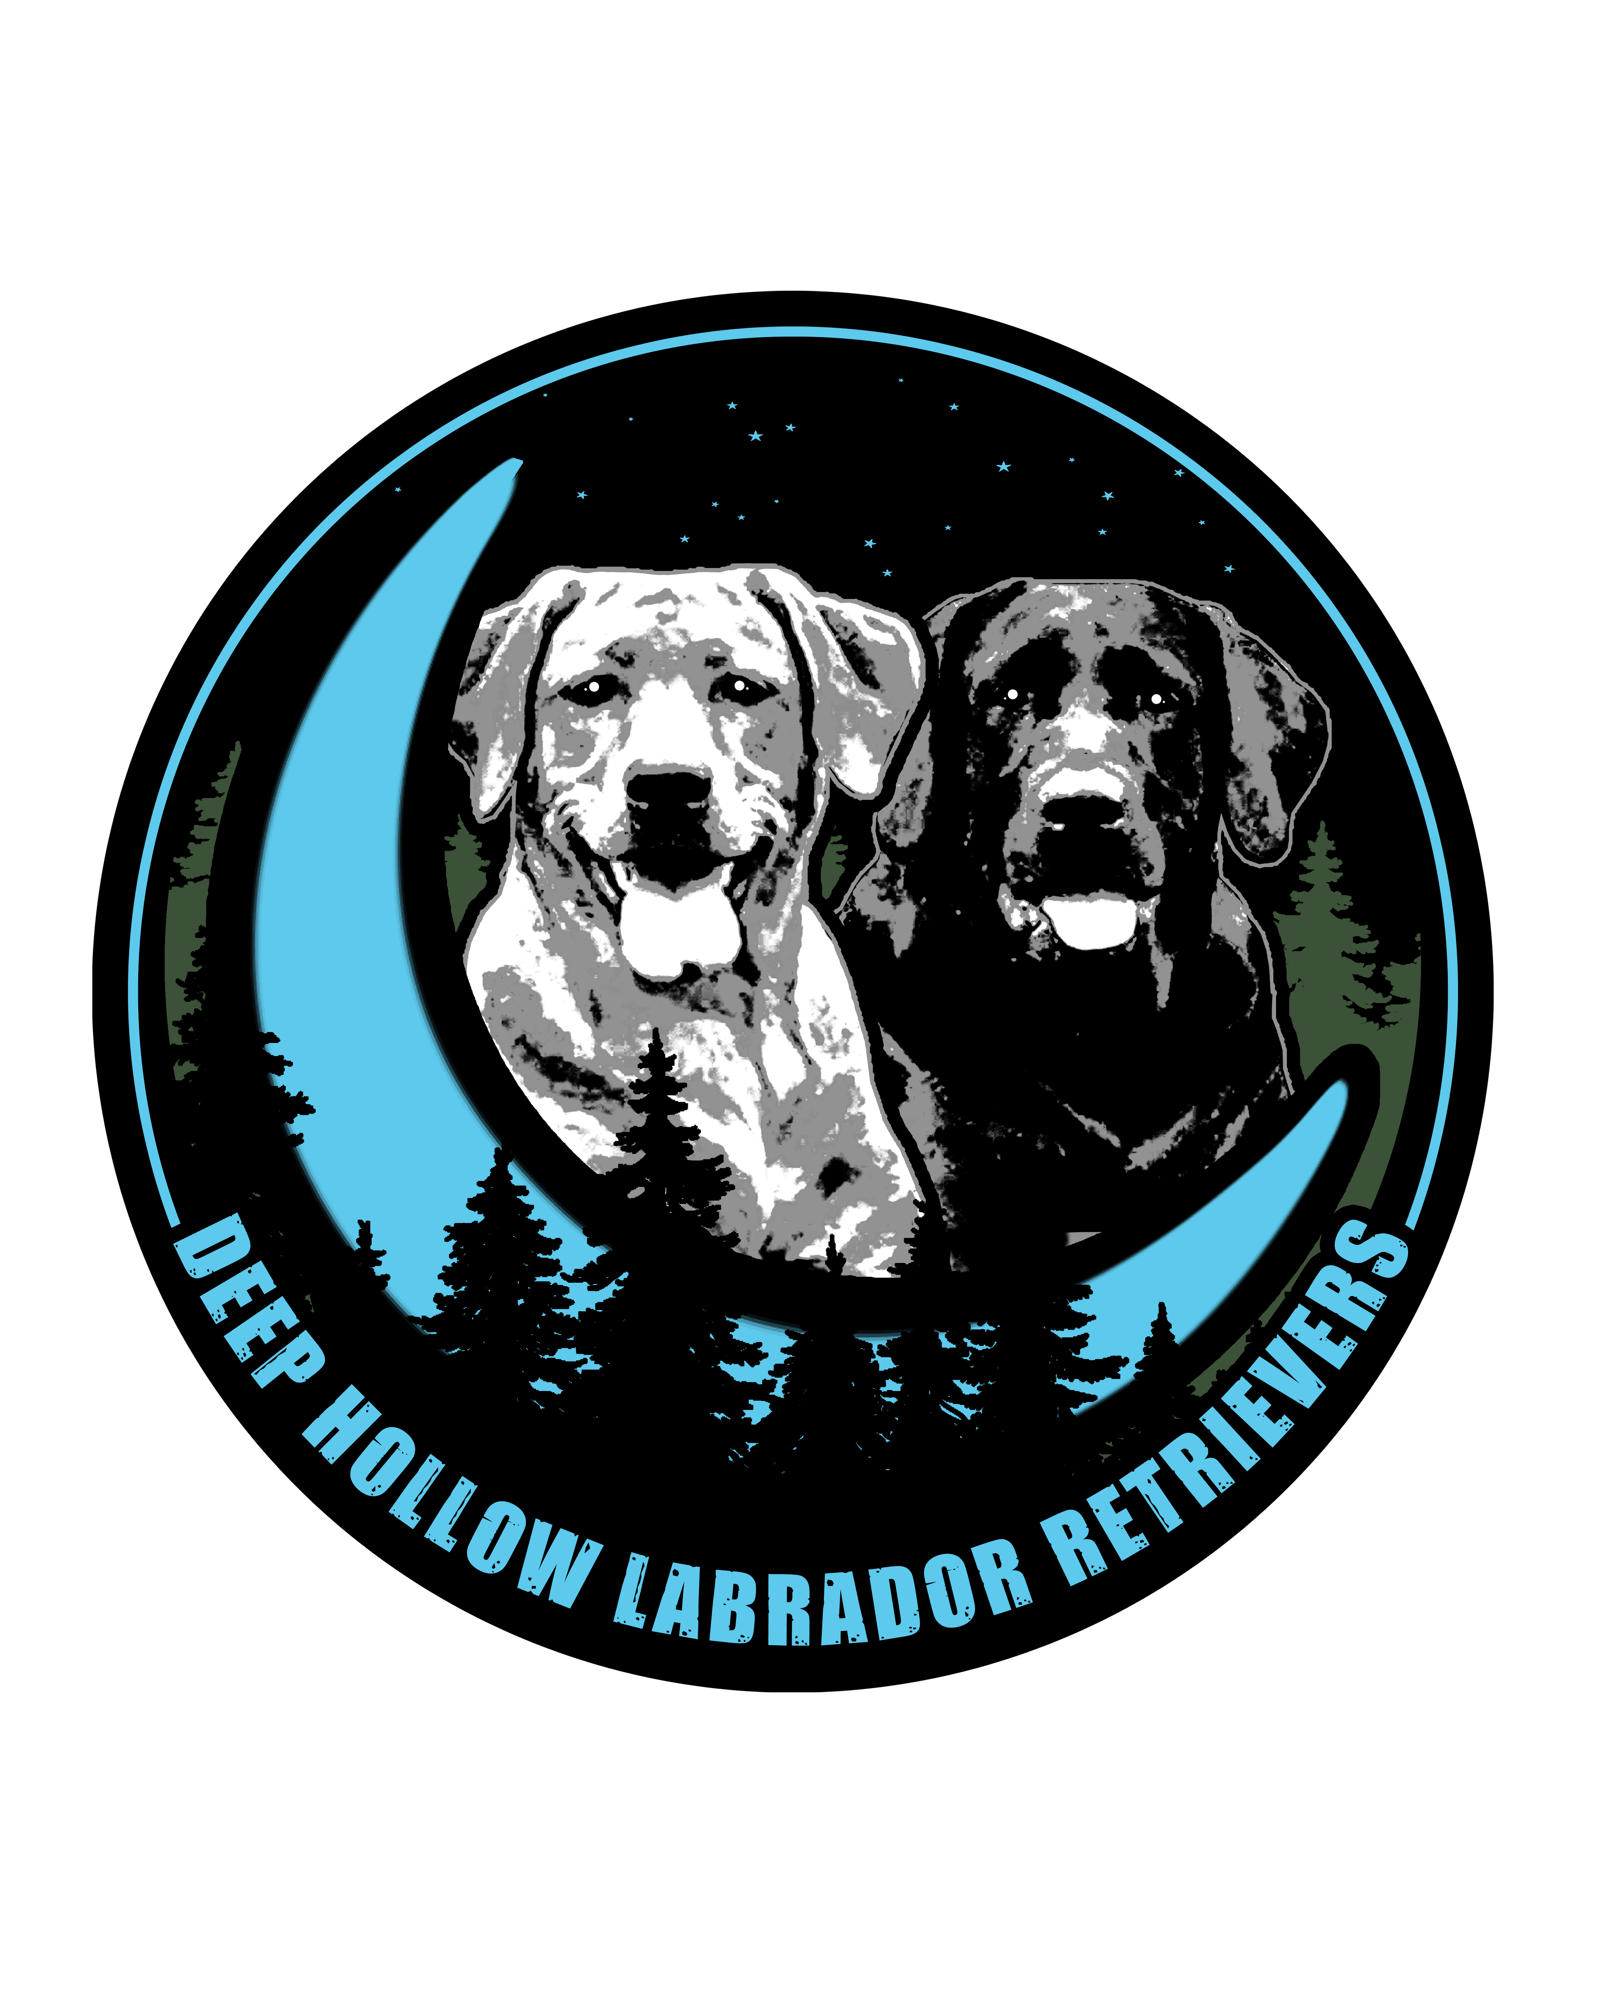
Deep Hollow Labrador Retrievers
Puppy Screening Questionnaire
Submission Date: Click here to enter a date.

Applicant Name(s): | First Name. Last Name  First Name. Last Name
Address: | Street Address
City, State, Zip: | City State.zip code
Phone (Cell): | Cell Phone
Phone (Home): | Home Phone
Email Address: | Email Address
How did you hear about us? Click to Select from Menu

If referred, please provide name: Name of person who referred you.

Puppy Interest/Criteria

What Sex of Puppy are you Interested in? | Select from Menu.
Are you interested in a particular color? | Select from Menu.
Who will be the primary caretaker of this puppy? | Name
Have you ever owned a dog before? | Select Box Y/N
Have you ever raised a puppy before? | Select Box Y/N
Are you interested in breeding this dog? | Select Box Y/N
Have you ever owned a Labrador Retriever? | Select Box Y/N
Are you familiar with different types/lines of the breed? | Select Box Y/N
Are you aware of the activity level and exercise needs of this breed? | Select Box Y/N
Are you aware that this breed sheds? | Select Box Y/N
Are you prepared to commit to a minimum of basic obedience training under the supervision of a professional? | Select Box Y/N

Please note: We do not sell our puppies based on color selection. We will keep your color preferences in mind when placing/making selections, but our primary goal is to place each puppy based on temperament, purpose and future goals for each puppy.

Please feel free to add any additional pertaining to what you are looking for in your new puppy:
Click here to enter text.

Puppy Interest/Criteria (continued)

- What is your primary interest in obtaining a Labrador Retriever? Click to enter text.
- What attract you to this breed? Click to enter text.
- Where will this puppy primarily live (Indoors/Outdoors) please explain? Click to enter text.
- Where will you leave the puppy when it is alone? Click to enter text.
- Is someone available to walk/potty the pup when you’re away? Click to enter text.
- Do you have items needed to raise a puppy (kennel/Crate, toys, etc)? Click to enter text.
- How do you intend to socialize this puppy? Click to enter text.
- Are you prepared for teething/chewing? Click to enter text.
- What kind of food do you feed? And, why? Click to enter text.

Are you willing to stay in contact with us, openly discuss any training or health problems you have, & agree to give us right of first refusal if you are unable/unwilling to keep the dog? Select Y/N

Are you willing to keep us informed of your puppy's progress with regular updates, photos and training progress? Select Box Y/N

Are you prepared to provide any necessary veterinary treatment, feed a high-quality food, license your Labrador Retriever as per your areas requirements and never allow him/her to be a neighborhood nuisance? Select Box Y/N

TRAINING INTERESTS & EXPERIENCE
Please complete the check list below so we are aware of your primary interests and experience
Purpose | Future Interest | Have Past or Current Experience | Years Experience (if any) | Explanation of Experience,  Trainers you have used,  and/or Titles you have earned (if any)
Family Companion
AKC/UKC HUNT TEST
Conformation Showing
Detection – Nosework - Scentwork
Obedience - Companion
Obedience - Competitive
Search & Rescue (S.A.R.)
Tracking
Rally
Therapy Dog
Dock Diving
Agility
Field Trials
Hunting Dogs - Personal
Member of a Breed or Competition Club
Other

BACKGROUND & HOME INFORMATION

Are there any pets in your home now? Select Box Y/N

Please List Your Pets below (or if you don’t currently own any, but have in past you can list those)

Name | Species | Breed | Sex | Spayed or Neutered? | Age?
Pet Name | Choose species | Breed | Choose Sex | Select | Age
Pet Name | Choose species | Breed | Choose Sex | Select Box Y/N | Age
Pet Name | Choose species | Breed | Choose Sex | Select Box Y/N | Age
Pet Name | Choose species | Breed | Choose Sex | Select Box Y/N | Age
Pet Name | Choose species | Breed | Choose Sex | Select Box Y/N | Age

Have you ever had a pet bite someone? Select Box Y/N
If yes, please explain Click here to enter text.
Have you ever given up a dog to a rescue, shelter or pound? Select Box Y/N
If yes, please explain Click here to enter text.

What is your occupation? | Occupation | How many hours are you away from home for work? Hours
Your significant others occupation? | Occupation | How many hours are they away from home for work? Hours

What is your living situation? (select from menu) | Select from menu
Do you Rent or Own? | Select from menu
How long have you lived there? | Length of Time
How many people live in this home? | How Many?
Do you have a fenced yard? | Select Box Y/N
How many acres is your property? | How Many?
Do you have Children? | Select Box Y/N
Are any children under the age of 7 years? | Select Box Y/N
Do you plan to have children (or more children) in the near future? | Select Box Y/N

Please feel free to add comments on your living situation: Click here to enter text.

REFERENCES
Please note the contacts listed below will be contacted for references.

Veterinary Information
Name of Practice: Click here to enter text.
Address: Click here to enter text.
Phone: Click here to enter text.
REFERENCES (continued)

Reference #1
Name: Click here to enter text.
Address: Click here to enter text.
Phone: Click here to enter text.
Email: Click here to enter text.
Reference #2
Name: Click here to enter text.
Address: Click here to enter text.
Phone: Click here to enter text.
Email: Click here to enter text.
Reference #3
Name: Click here to enter text.
Address: Click here to enter text.
Phone: Click here to enter text.
Email: Click here to enter text.

